**Level 1: PC Tower Case**

**Outline**

Learn about the internals of a standard PC case by examining physical samples and selecting and labeling images found on-line. Gain deeper knowledge by researching and reporting on specific components.

**Questions**

1. Find one (or more) images that clearly show the internals of a PC Tower Case.   
   (i.e. Google images using keywords “PC Case Internals”)  
   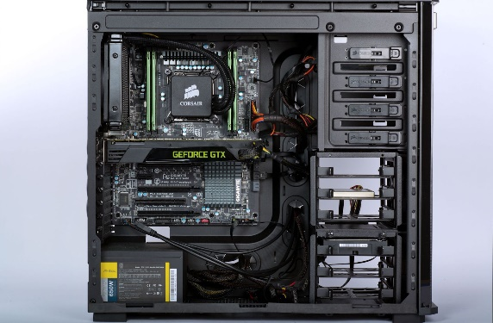
2. Clearly label the following components (using arrows) on your image of the PC case internals:

PC Internals

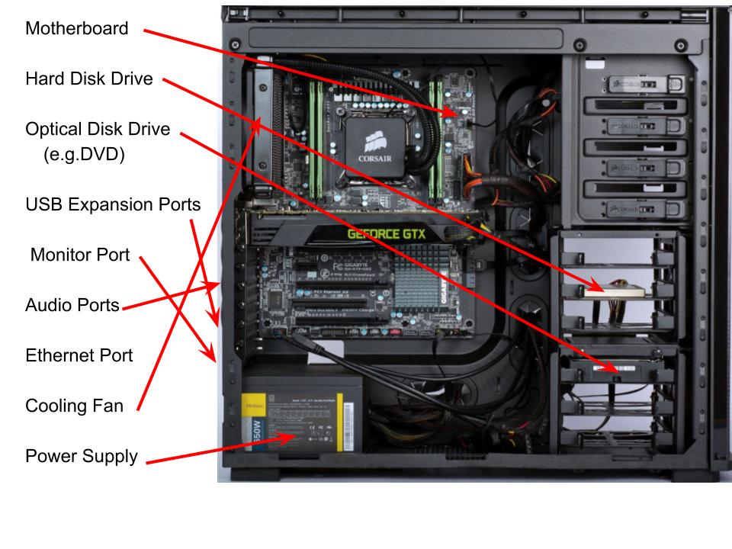

1. Research more in-depth about “Motherboards”. Make notes on the following:
   1. What different versions are currently available (speed and capacity)

The FSB speeds can range from 66 MHz to over 800 MHz. V recent years.

* 1. How the component has changed since the 1980’s

Changes in the processor design, like a new socket with a different number of pins

1. Research more in-depth about “Hard Disk Drives”. Make notes on the following:
   1. What different versions are currently available (speed and capacity)

Platters spin at either 5400 Revolutions per Minute or 7200 Revolutions per Minute some even spin at 15,000 Revolutions per Minute

* 1. How the component has changed since the 1980’s  
     The components became smaller faster and have more storage.

**NOTE:**

* Download the on-line version of this module (from the class GitHub repository)
* Questions for Level 2 and Level 3 are in the on-line version of this module
* Provide your answers in a MS Word, PowerPoint, or equivalent format
* Upload your answers to your personal GitHub repository

**Level 2: PC Motherboard**

**Outline**

Learn about the structure of a standard PC motherboard by examining physical samples and selecting and labeling images found on-line. Gain deeper knowledge by researching and reporting on specific components.

**Questions**

1. Find one (or more) images that clearly show the layout of a PC Motherboard.   
   (i.e. Google images using keywords “PC Motherboard”)  
   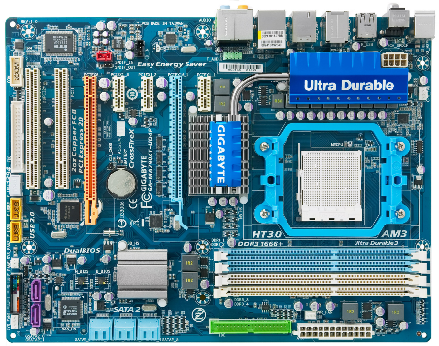
2. Clearly label the following components (using arrows) on your image of the PC motherboard:

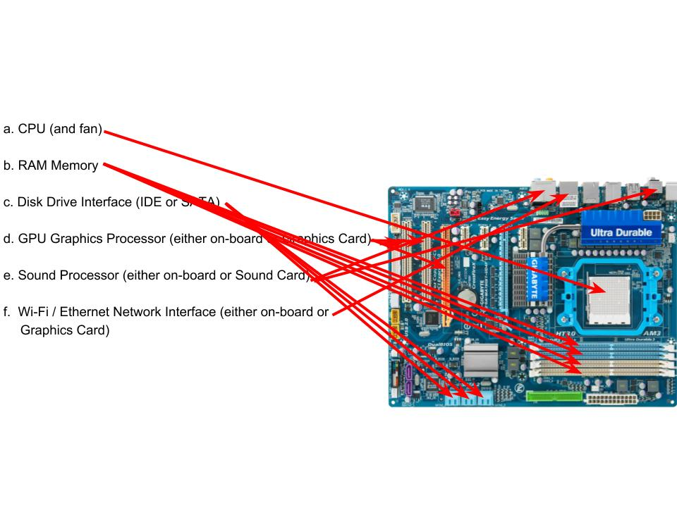

1. Research more in-depth about “CPU Processor Chip”. Make notes on the following:
   1. What different versions are currently available (speed and capacity)

The CPUs currently available are the [AMD Ryzen 2nd Generation](https://www.techradar.com/news/amd-ryzen-2nd-generation), [Coffee Lake Refresh](https://www.techradar.com/news/intel-coffee-lake-refresh),  [i9-9900K](https://www.techradar.com/reviews/intel-core-i9-9900k-review), [Ryzen 3 2200G](https://www.techradar.com/reviews/amd-ryzen-3-2200g),  [AMD’s Threadripper 2nd Generation](https://www.techradar.com/news/amd-ryzen-threadripper-2nd-generation), [Basin Falls Refresh](https://www.techradar.com/news/intel-basin-falls-refresh), [Kaby Lake](https://www.techradar.com/news/computing-components/processors/kaby-lake-intel-core-processor-7th-gen-cpu-news-rumors-and-release-date-1325782), [AMD Ryzen 7 2700X](https://www.techradar.com/reviews/amd-ryzen-7-2700x), [Intel Core i9-9900K](https://www.techradar.com/reviews/intel-core-i9-9900k-review), [AMD Ryzen 5 2600X](https://www.techradar.com/reviews/amd-ryzen-5-2600x), [AMD Ryzen 7 1800X](https://www.techradar.com/reviews/amd-ryzen-7-1800x), and  [Intel Core i9-9980XE](https://www.techradar.com/reviews/intel-core-i9-9980xe)

* 1. How the component has changed since the 1980’s  
     the change to the component is “chips have wider registers and can address more memory”.

1. Research more in-depth about “RAM Memory”. Make notes on the following:
   1. What different versions are currently available (speed and capacity)

The versions currently available are Static RAM (SRAM), Dynamic RAM (DRAM), Synchronous Dynamic RAM (SDRAM), Single Data Rate Synchronous Dynamic RAM (SDR SDRAM), Double Data Rate Synchronous Dynamic RAM (DDR SDRAM, DDR2, DDR3, DDR4), Graphics Double Data Rate Synchronous Dynamic RAM (GDDR SDRAM, GDDR2, GDDR3, GDDR4, GDDR5), and Flash Memory

* 1. How the component has changed since the 1980’s

The component has gotten small and can now addresses more memory.

**Level 3: Peripheral Devices**

**Outline**

Learn about how peripheral devices are connected to the back side of a typical PC tower case. Examine physical samples, select and labeling images found on-line and gain deeper knowledge by researching and reporting on specific components.

**Questions**

1. Find one (or more) images that clearly show the layout of the back of a typical PC tower case.   
   (i.e. Google images using keywords “Back Of PC Tower”)  
   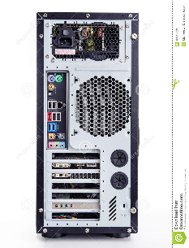
2. Clearly label the following components (using arrows) on your image of the back of a typical PC tower case:

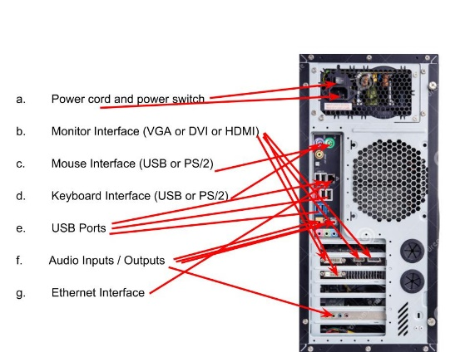

1. Research more in-depth about “Monitor Technology”. Make notes on the following:
   1. What different versions are currently available (e.g. VGA / DVI, Flat Panel Technology))

“Versions currently available for VGA are A VGA cable with DE-15 male connector and VGA BNC connectors, for DVI are DVI-I integrated, combines digital and analog in the same connector; digital may be single or dual link, DVI-D digital only, single link or dual link, and DVI-A (analog only) and finally for Flat Panel Technology there are Liquid Crystal Displays (LCDs), Field Emission Displays(FEDs), Light Emitting Diodes (LEDs), and Plasma Display Panels (PDPs)”

* 1. How the component has changed since the 1980’s (e.g. Display Resolution, Technology)

The component now has higher resolution, more pixels, brighter, touch screens, faster screens and bendable screens.

1. Research more in-depth about “External Portable Storage”. Make notes on the following:
   1. Floppy Disks
   2. CD-ROM / DVD / Recordable CD/DVD
   3. USB Memory Drives
   4. Compact Flash Memvgory
   5. Cloud Based Storage

**Level 4: PC Component Presentation**

**Outline**

Explore the development and features of a specific PC hardware component through deeper research and investigation. Work in partners to create a short presentation. Deliver the presentation to the class.

Each group will research a unique PC hardware component . Your specific topic will be assigned from the list provided below.

**Presentation Structure**

1. Explain what the PC component does and how it fits together with other components to make up a fully functioning PC.
2. Explain how the PC component works. Provide a diagram (image) showing the main parts of the component.
3. Research the current state of the art of the component in terms speed, capacity (size), and other related factors.
4. Research on-line suppliers that sell the PC Component. List the specifications for the available products and the cost (price).
5. Research how the PC component has changed and evolved since the early days of PCs in the 1980’s. Cover each of the following topics separately:
   1. Component Speed
   2. Component Size / Capacity
   3. Two other specifications specific to the PC component (ask Mr. Nestor)

**PC Component Topics**

|  |  |  |
| --- | --- | --- |
| **Topic** | **Partner 1** | **Partner 2** |
| CPU Microprocessor Chip |  |  |
| Motherboard Layout |  |  |
| Computer Graphics |  |  |
| Sound & Audio |  |  |
| Hard Disk Drives |  |  |
| Removable Disk Storage |  |  |
| Network / Internet Connectivity |  |  |
| Mouse / Pointing Devices |  |  |
| Monitor & Display Technology |  |  |
| Printers & Output Technology |  |  |

CITATION

<https://www.google.com/search?authuser=1&tbm=isch&q=pc+insides&chips=q:pc+insides,g_1:desktop:6DuyQsq4-rs%3D&usg=AI4_-kRlMRWyTpe0ZXoPX1_FH9Q1e1v3dQ&sa=X&ved=0ahUKEwiUkamd8rngAhVHRqwKHVuzAw0Q4lYIKCgB&biw=1404&bih=699&dpr=1.35#imgrc=1Vf9-MxJUwW24M>:

<https://www.google.com/search?q=Back+Of+PC+Tower&rlz=1C1SQJL_enCA819CA820&source=lnms&tbm=isch&sa=X&ved=0ahUKEwid2fzLj8bgAhXIrIMKHRcEAygQ_AUIDigB&biw=1422&bih=642#imgdii=TGW0fU9ryJl-6M:&imgrc=-KbGTQwgWHxrtM>:

<https://en.wikipedia.org/wiki/Computer_display_standard>

<https://www.google.com/search?q=pc+motherboard&rlz=1C1SQJL_enCA819CA820&source=lnms&tbm=isch&sa=X&ved=0ahUKEwit8vOTpcbgAhUF3YMKHTfpCGUQ_AUIDigB&biw=1422&bih=588#imgdii=B5uHYCAdM_qSHM:&imgrc=0o-ZbV0FTVlavM>:

<https://www.storagereview.com/ssd_vs_hdd>

<https://www.pcworld.com/article/127105/article.html>

[www.dicardiology.com](http://www.dicardiology.com)

en.wikipedia.org

<https://obsoletemedia.org/5-25-inch-hard-disk-drive/>

<https://computer.howstuffworks.com/motherboard4.htm>

<https://www.canadacomputers.com/index.php?cPath=26>

<https://en.wikipedia.org/wiki/Motherboard>

<https://www.hardwarezone.com.sg/m/feature-hardwarezones-10th-anniversary-special/motherboard-evolution-decade>

danluu.com

[www.lifewire.com](http://www.lifewire.com)

[www.computerhistory.org](http://www.computerhistory.org)  
[www.computerworld.com](http://www.computerworld.com)

[www.reddit.com](http://www.reddit.com)

[www.computerhope.com](http://www.computerhope.com)

[www.britannica.com](http://www.britannica.com)

mashable.com

searchstorage.techtarget.com

whatis.techtarget.com